***William Percy’s Group of Handwriting Variants***

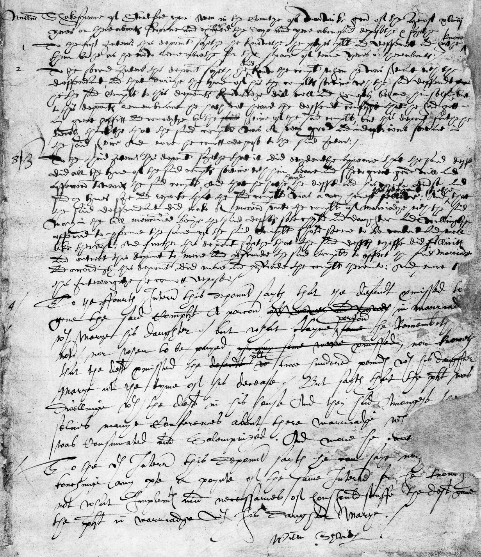

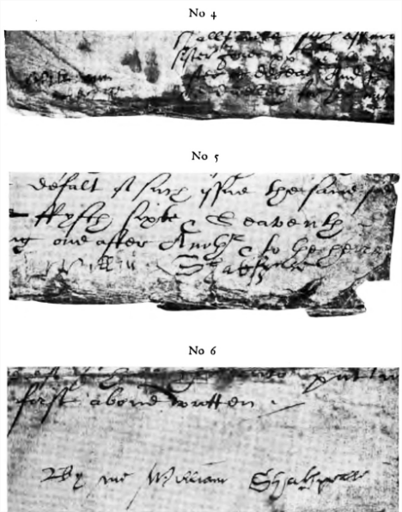

Three Legal Documents with “Shakespeare” Signatures (Maunde)

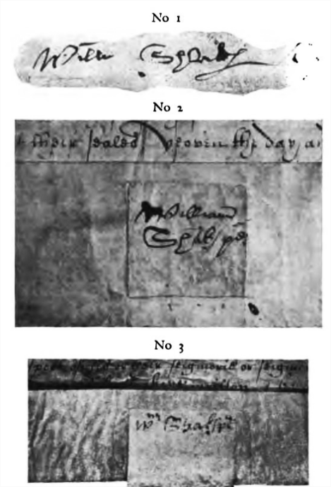

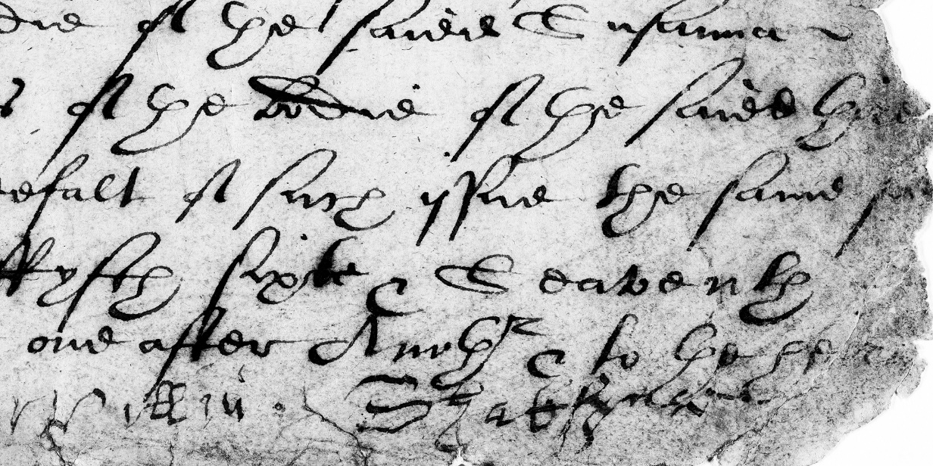

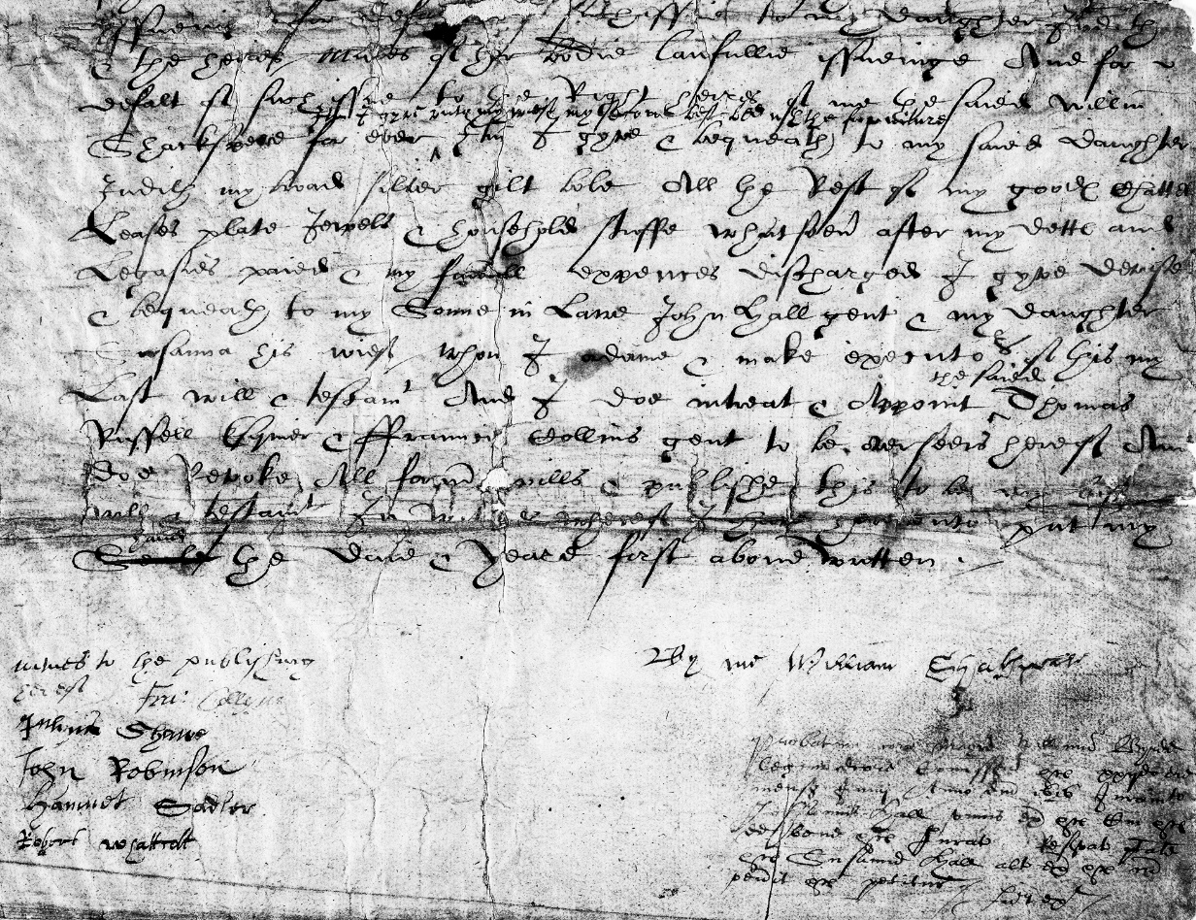

“Shakespeare’s” Will Signatures (Maunde)

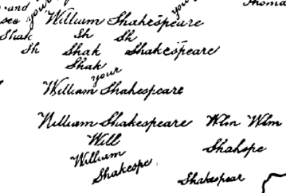

*Northumberland MS*: “Shakespeare” Handwriting Exercises

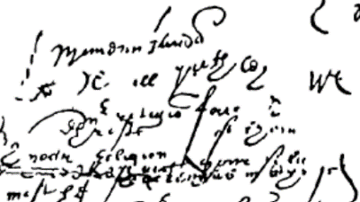

*Northumberland MS*: Scribbles

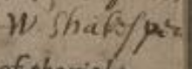

“Shakespeare’s” name in annotation on “Greene’s” *Pleasant Conceited Comedy*

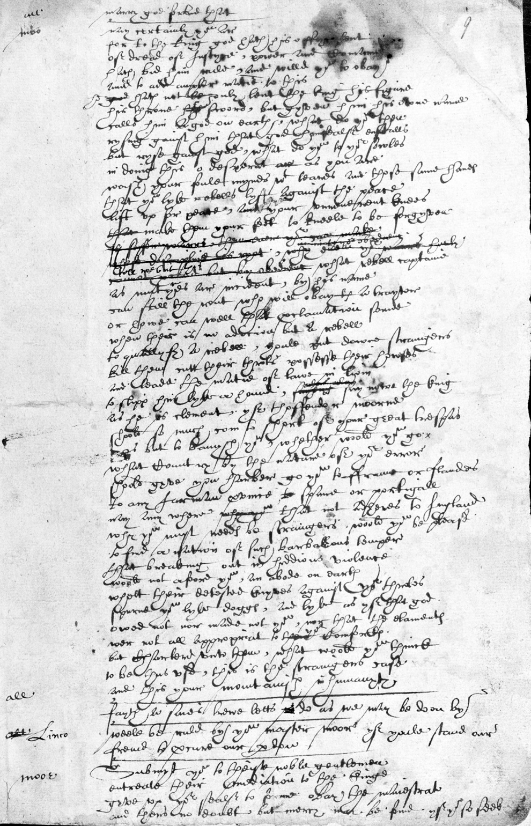

“*The Book of Sir Thomas Moore*: Shakespeare’s Handwriting in the *Harley MS 7368*, folio page 9r.” (British Library, 1601-4).

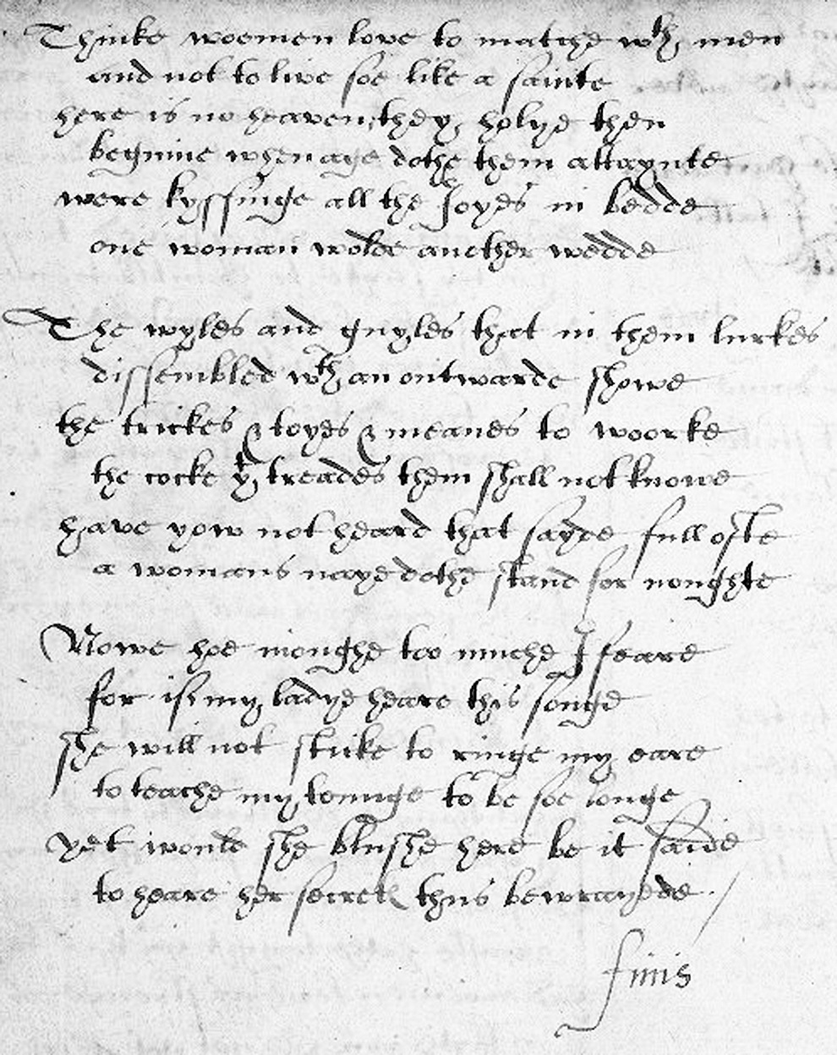

“Anne Cornwallis’ Poetical Miscellany with an Early Apocryphal Poem by Shakespeare”, V.a.89, page 26 (Washington DC: Folger Shakespeare Library, 1590/1600?).

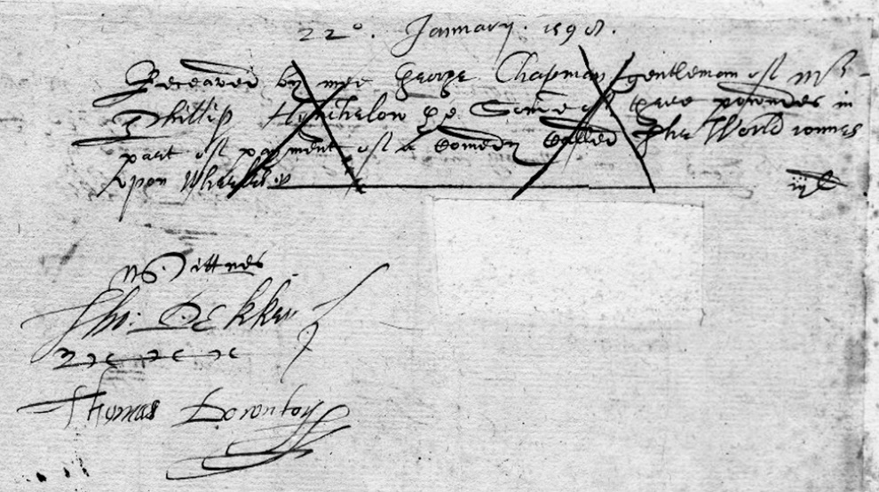

“Cancelled Receipt by George Chapman, gent., of a £3 loan from Philip Hynchelow in part payment of a comedy, *The World Runs upon Wheels*, January 22, 1599. Witnessed by Thomas Dekker and Thomas Downton” (Folger Shakespeare Library).

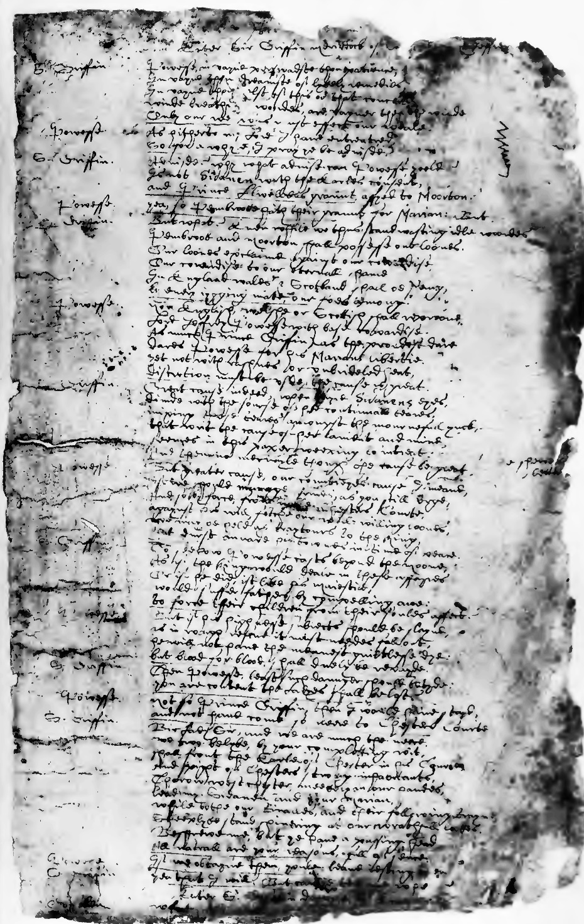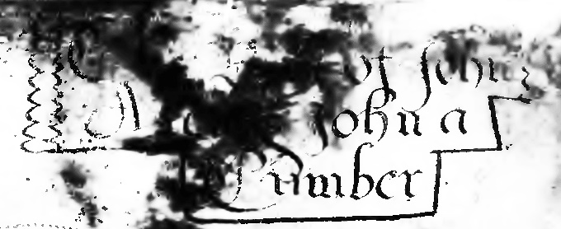

*John-a-Kent and John-a-Cumber* manuscript in “Munday’s autograph” (December 1595; reprinted in facsimile in John S. Farmer’s *The Tudor Facsimile Texts*: 1912).

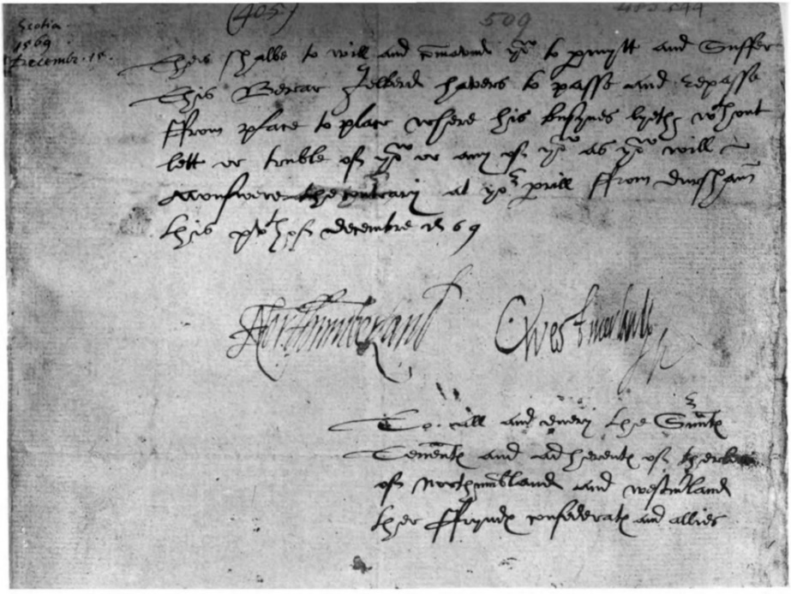

“Facsimile of Passport Signed by Thomas Seventh Earl of Northumberland [1528-72], and the Earl of Westmoreland [1542-1601]”: *AHP*.

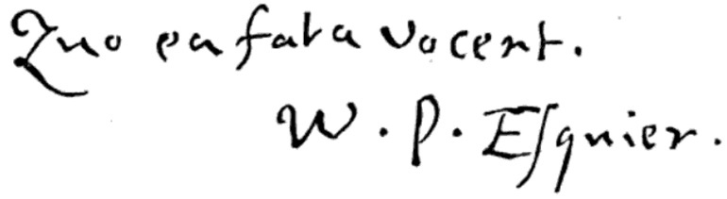

William Percy’s Signature on the Title-Page of His Self-Attributed Manuscripts (*HEDP*).

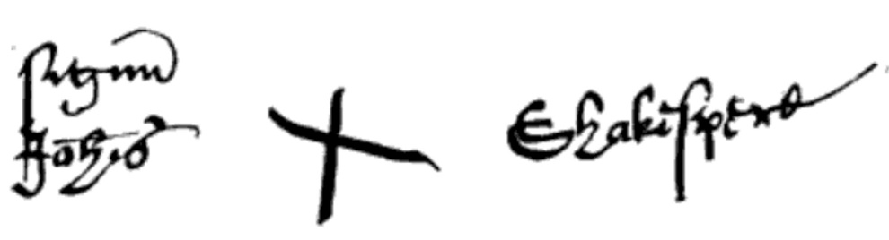

“Johannem Shakespe’s” Signature on “A Deed of Conveyance, from John Shakespeare to George Badger, of a slip of land belonging to the Birth-Place estate, January 1596-7” (*Outlines of the Life of Shakespeare*, Volume 2).

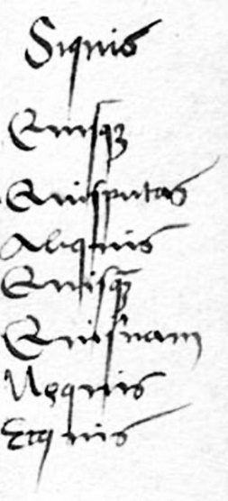

Potentially Percy’s Handwriting on the Quoted Alexander Brassicanus’ *Istitutiones Grammaticae* (1516?).

***Josuah Sylvester’s Group of Handwriting Variants***

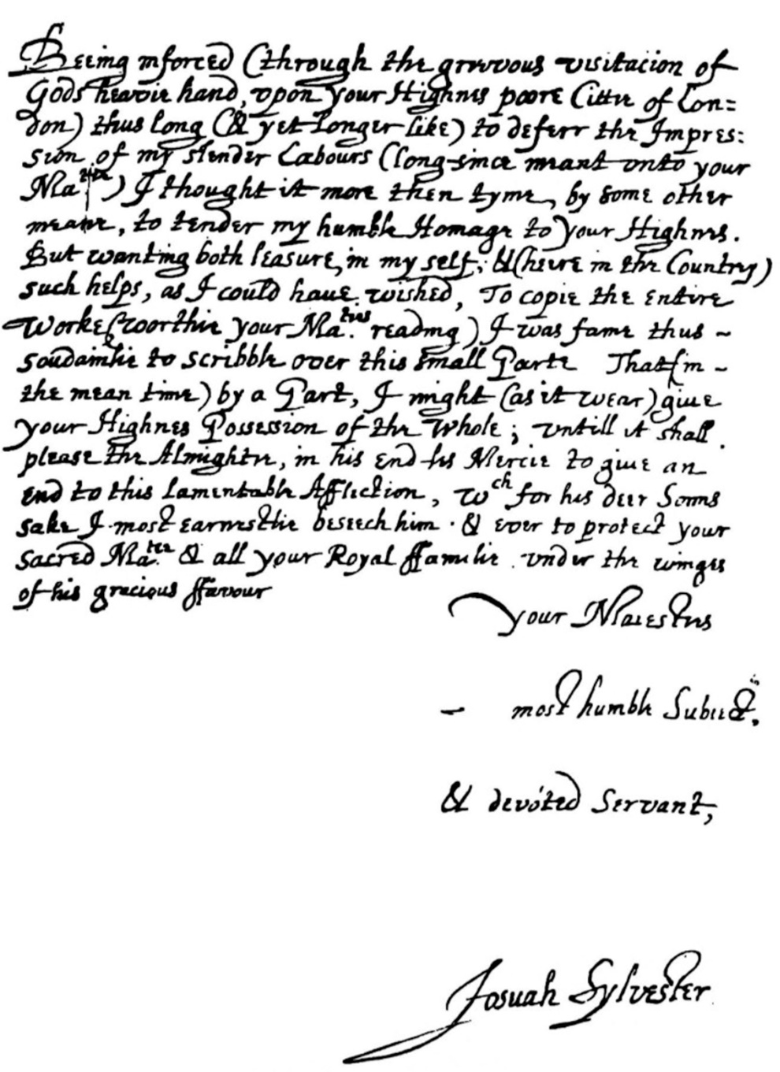

Josuah Sylvester’s Dedication Letter to James I from the 1603 edition of *Du Bartas.* From: *English Literature: An Illustrated Record*.

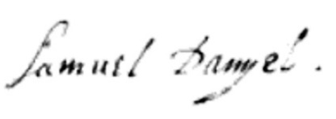

“Samuel Daniel’s” signature from the MS. Copy of *Panegyric Congratulatory to King James* (Royal MSS. XVIII, A. 72). From: *Autographs*.

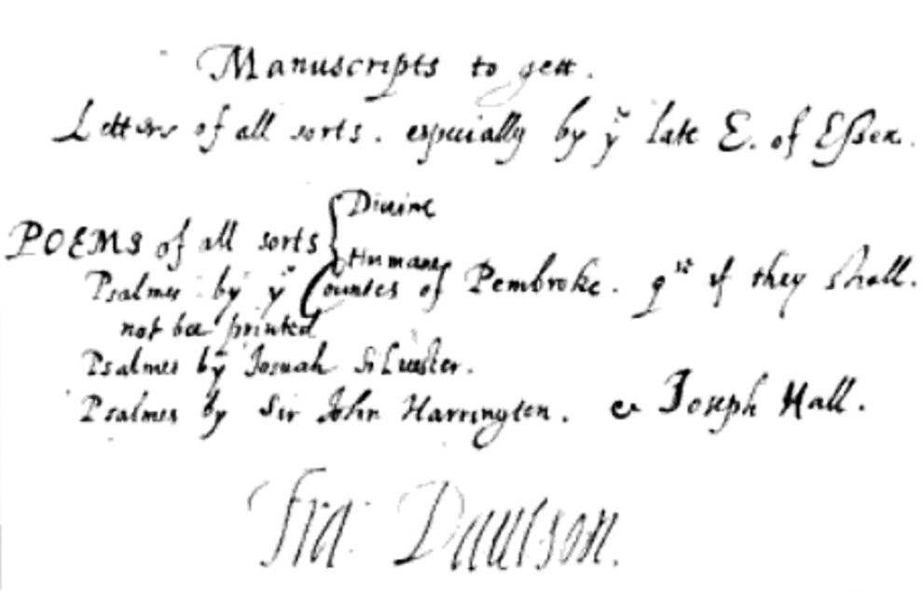

“Francis Davison’s” autograph from Harl. MSS. 298, fol. 157, b. with planned pieces for the forthcoming *Poetical Rhapsody*: “His Signature is added from another authority.” From: *Autographs*.

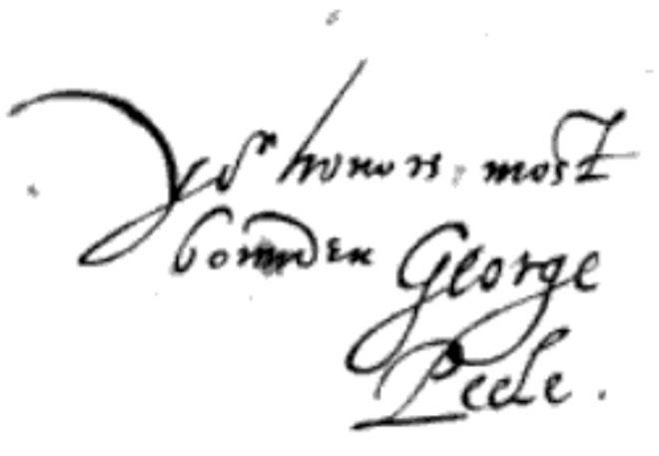

“George Peele’s” signature from a letter to “Lord Burleigh” in the Lansdowne MSS. 99, fol. 54. From: *Autographs*.

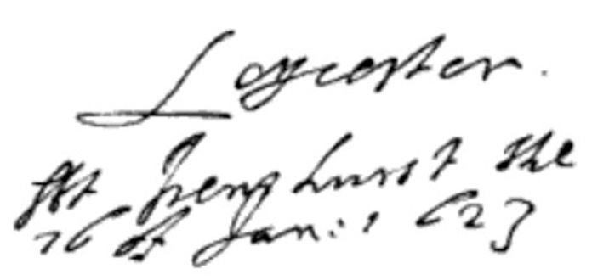

“Robert Sidney’s” Handwriting: “At Penshurst, the 16 of Jan. 1623”. *Harl. MSS. 7000, fol. 72*, as printed in *Autographs*.

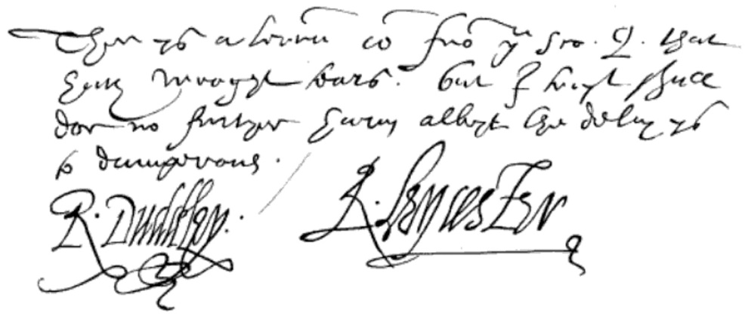

“Robert Dudley, Earl of Leicester’s” Handwriting: “There is a letter come from you Sco. Q. that has wrought tears; but I trust shall do no further harm, albeit the delay is too dangerous.” From a letter to Walsingham. *Harl. MSS. 285, fol. 268*, as printed in *Autographs*.

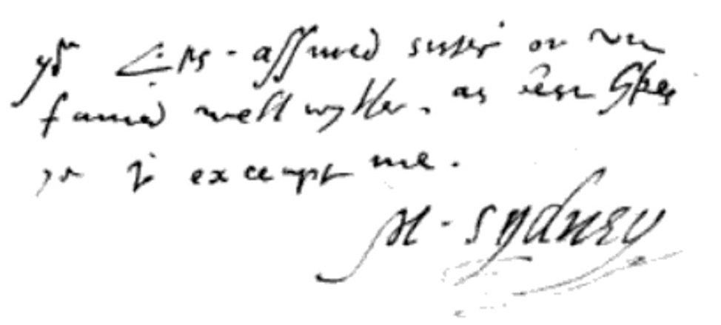

“Mary Sidney’s” Handwriting: “Your L’p’s assured sister, or unfeigned well wither, as best likes you to accept me, M. Sydney”. From a letter to Mary Sidney’s brother-in-law, Earl of Sussex, in Cotton. *MSS. Titus, B. 11. Fol. 305*, as printed in *Autographs*.

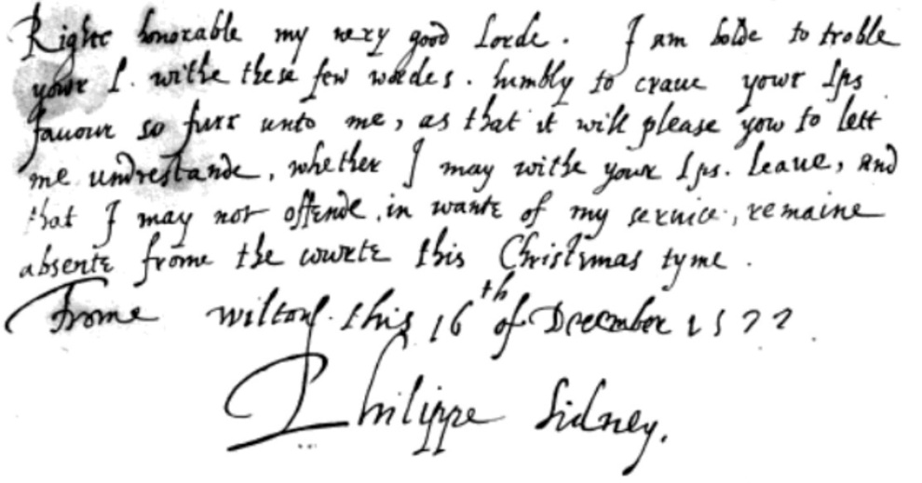

“Sir Philip Sidney’s” Handwriting: “Right honorable my very good Lord, I am bold to trouble your L. with these few words, humbly to crave your Lordship’s favor so far unto me, as that it will please you to let me understand, whether I may, with your Lordship’s leave, and that I may not offend in want of my service, remain absent from the court this Christmas time. From Wilton, this 16th of December, 1572. Philippe Sidney.” From a letter to Philip’s uncle, Earl of Leicester. *Harl MSS. 6992, fol. 42*, as printed in *Autographs*.

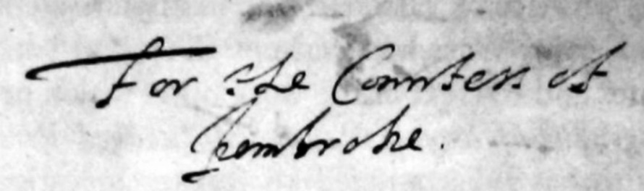

“Robert Sidney’s” autograph inscription, “For the Countess of Pembroke”, on the initial leaf (fol. I) of *MS. 58435* (British Library).[1]

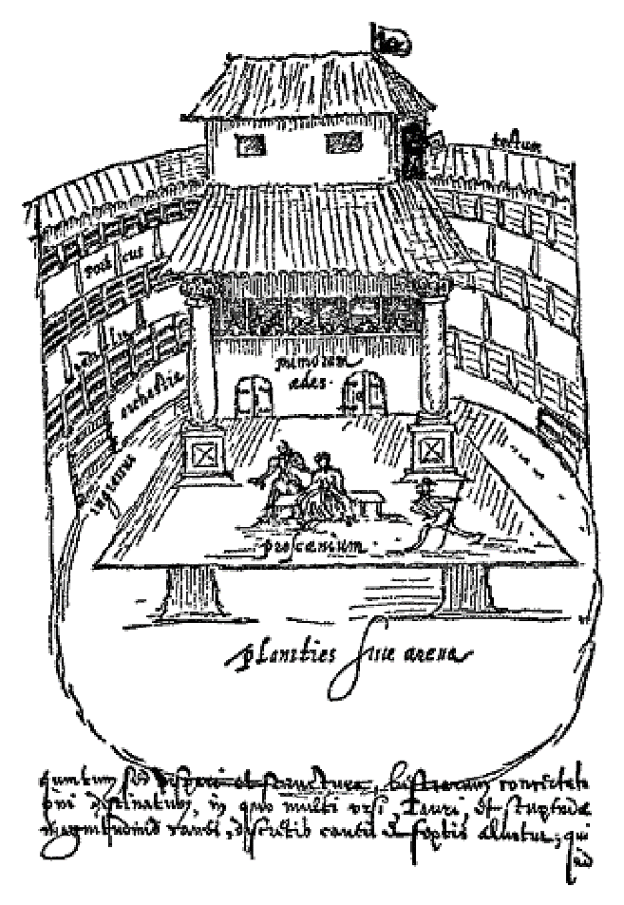

Interior of the Swan Playhouse: Sketched by “Johannes de Witt” in 1596 (*SP*).

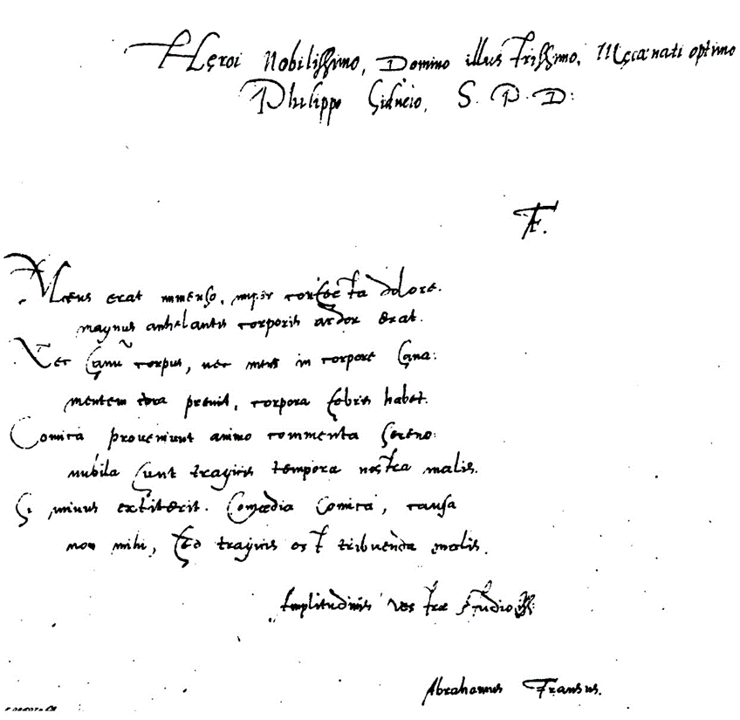

“Abrahamus Fransus” Autograph Dedication on *Victoria* in the *Penshurst MS* (From Smith’s Facsimile).

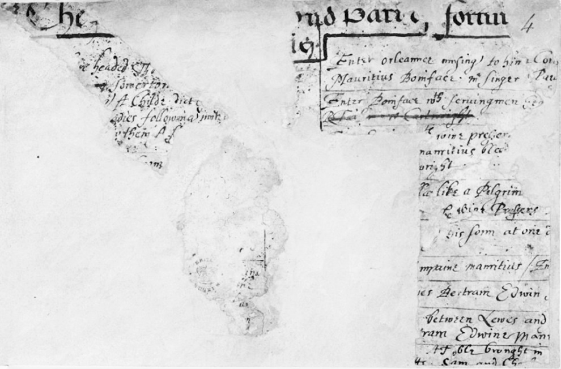

“*The Second Part of Fortune’s Tennis* (fragmentary)”, *Add MS 10449*, f. 4r (British Library, 1600-3?).

**Ben Jonson’s Group of Handwriting Variants**

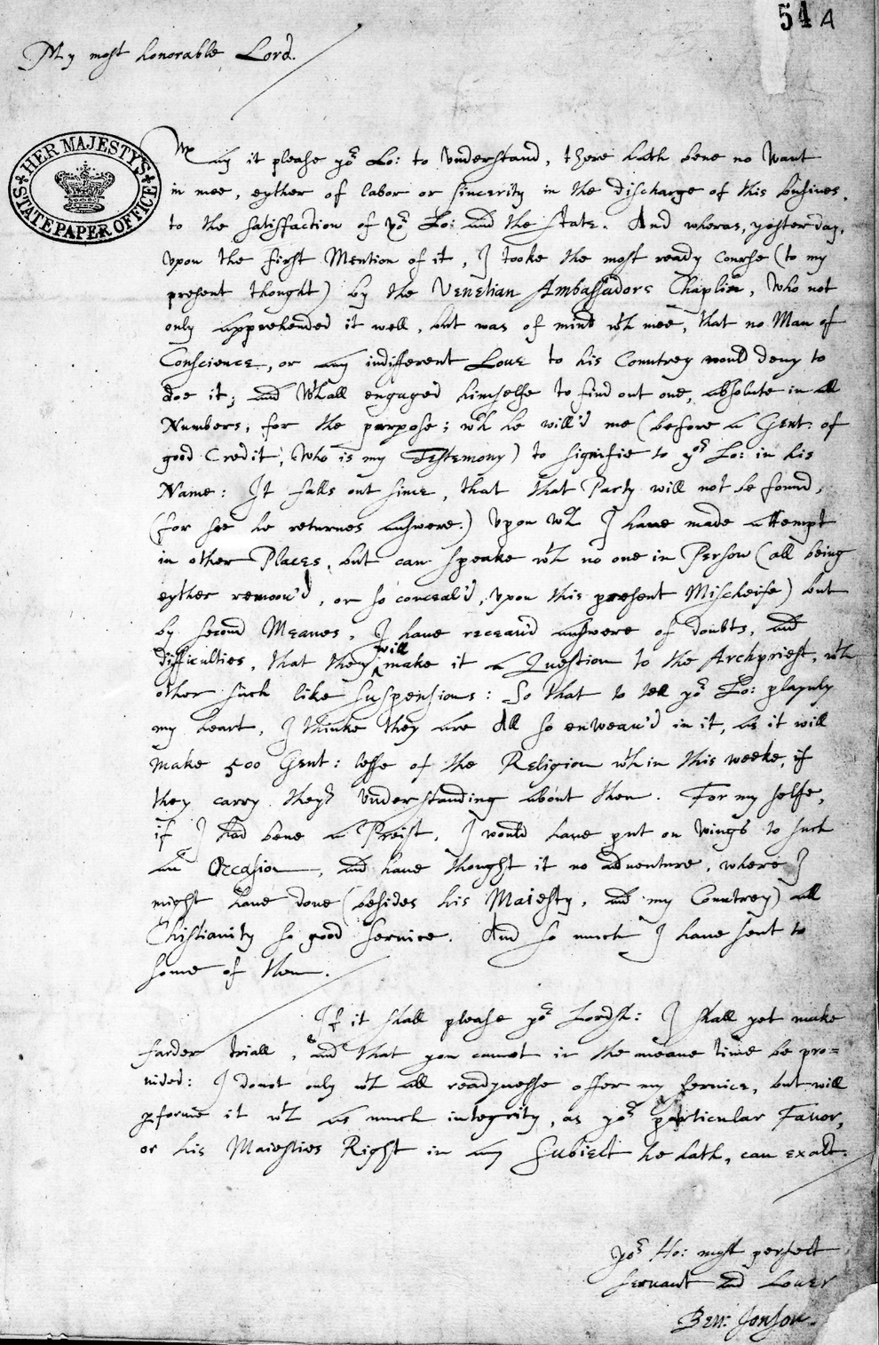

“Autograph Letter from Ben Jonson to Robert Cecil, Earl of Salisbury Concerning the Gunpowder Plot, 1605” (National Archives, London).

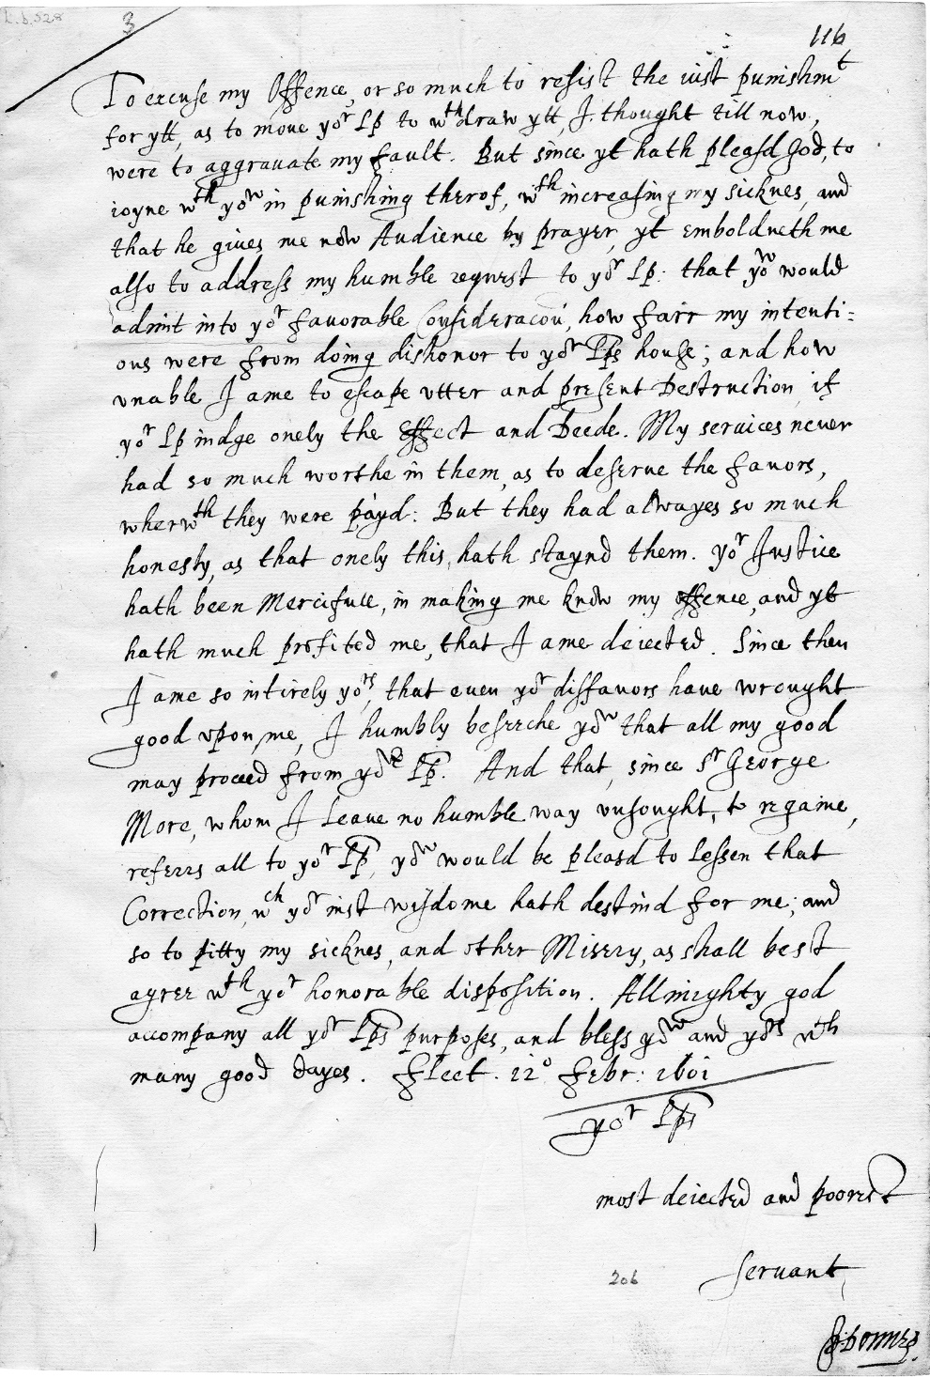

“Autograph letter signed from John Donne, Fleet Prison, to Sir Thomas Egerton, 1601/1602 February 12” (Washington DC: LUNA: Folger Digital Image Collection).

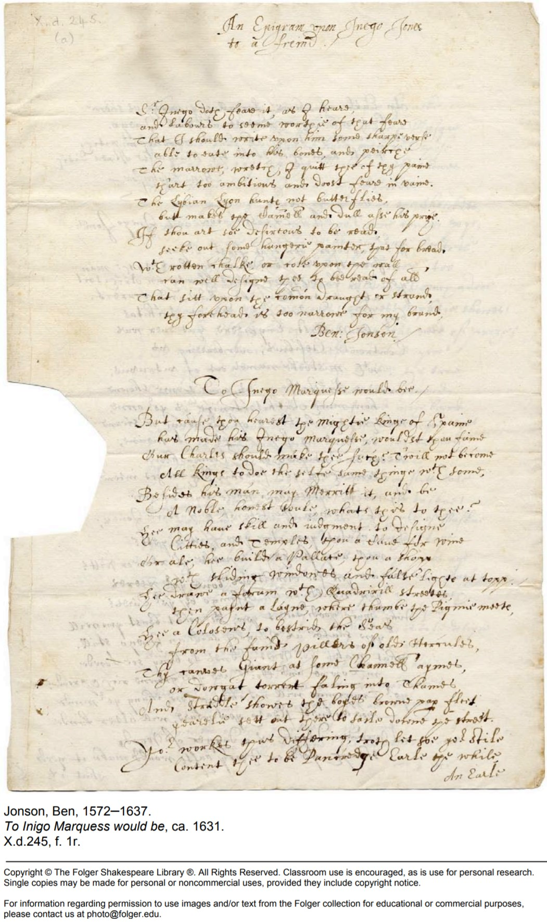Benjamin Jonson, “To Inigo Marquess would be” (Folger Shakespeare Library, 1631?).

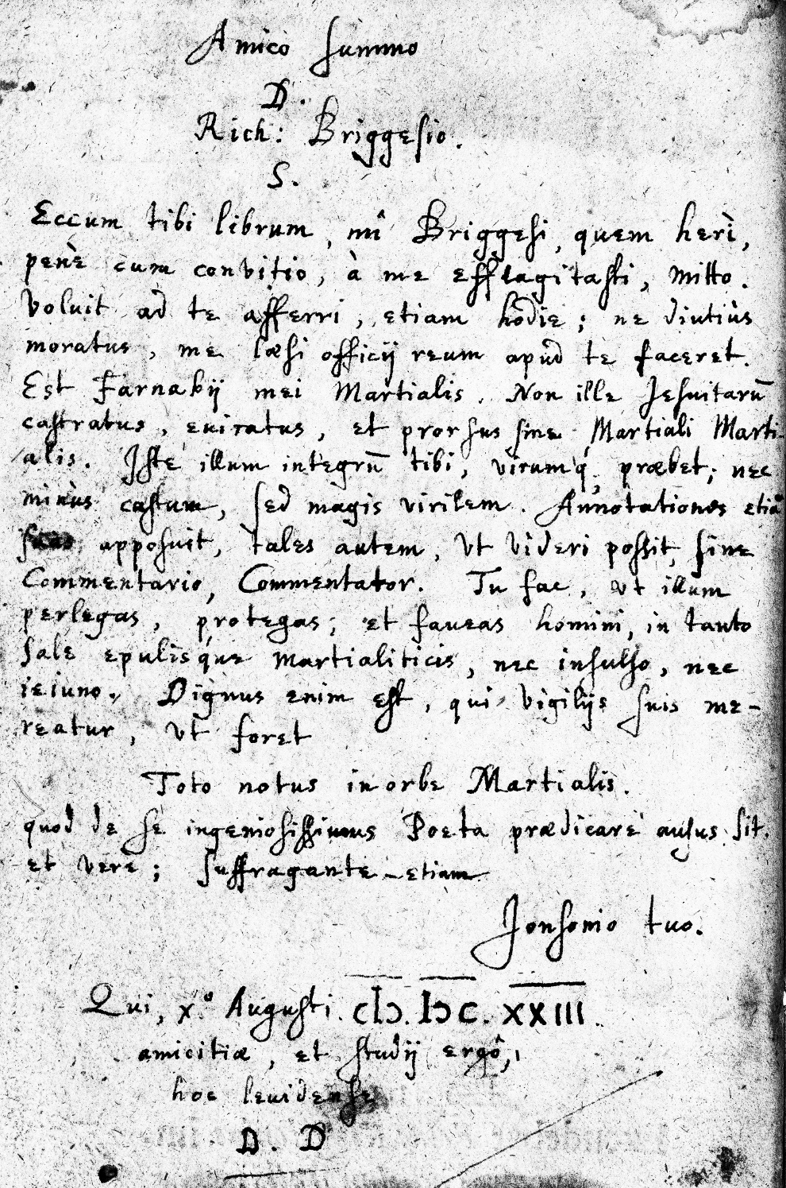S.

Jonson’s Letter on Martial’s *Epigrams* (London, 1615; Folger Shakespeare Library).

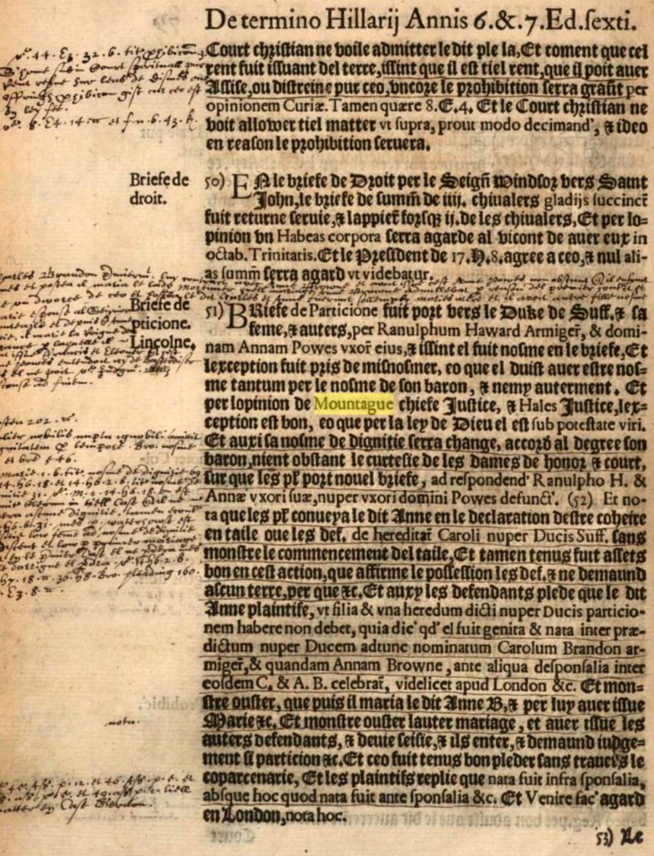

Potential Example of Jonson’s Handwriting in “B.L’s” *Cy ensuont ascun novel Cases, collectes per le jades tresreverend Judge, Mounsieur J. D.* (London, 1601).

**Gabriel Harvey’s Group of Handwriting Variants**

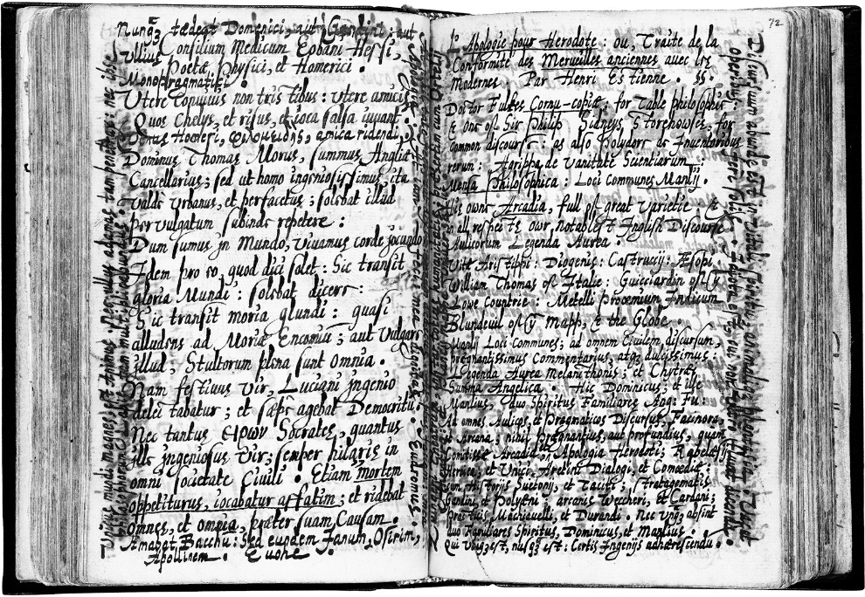

“Annotations by Gabriel Harvey in *Facetie, motti, et burle di diversi signori et persone private and Detti, et fatti piacevoli et gravi, di diversi principi filosofi, et cortigiani*” (Washington, D.C., Folger Shakespeare Library).

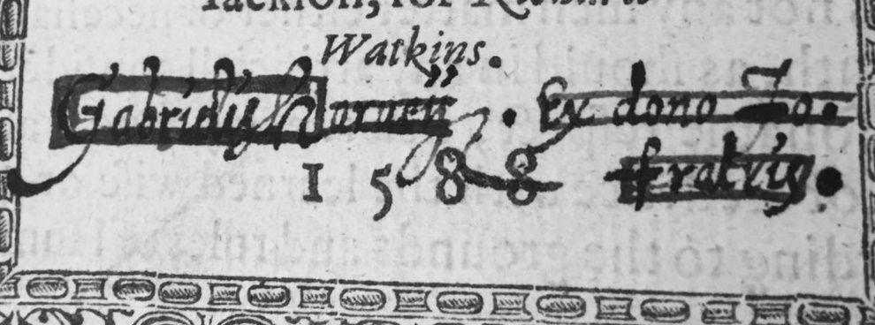

Gabriel Harvey Strikes Out His Handwritten Name on His Brother, “John Harvey’s” *A Discursive Problem Concerning Prophesies* (1588), “STC 12908 copy 2” (Washington, D.C., Folger Shakespeare Library).

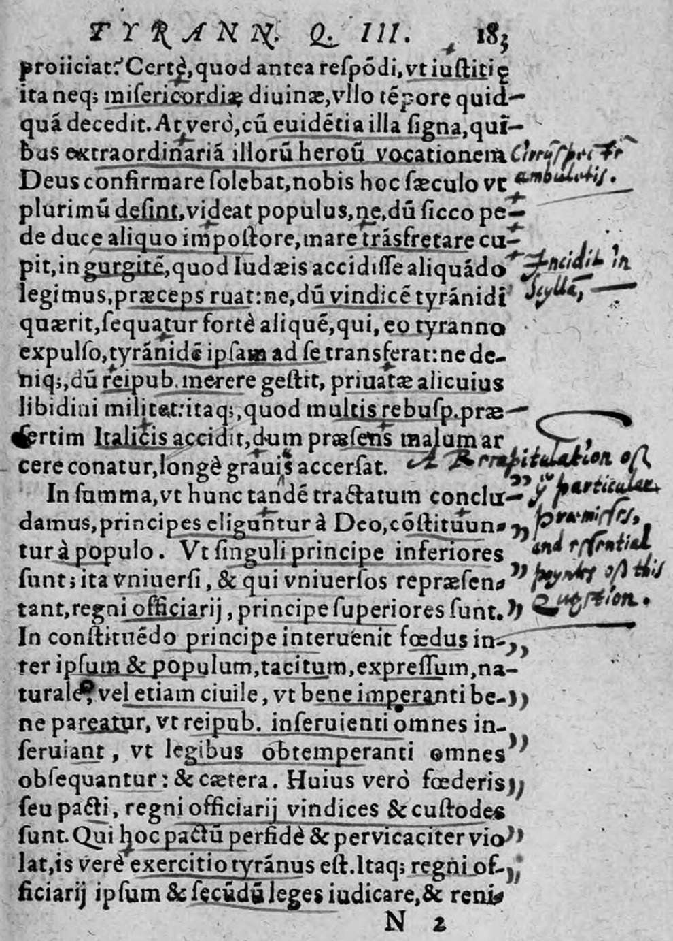

Gabriel Harvey’s Annotations on *Nicolai Machiavelli Princeps Adiecta sunt eiusdem argumenti aliorum quorundam contra,* “Tyrannus”/“Tyrant”, page 183 (1580; Llyfrgell Genedlaethol Cymru: The National Library of Wales).

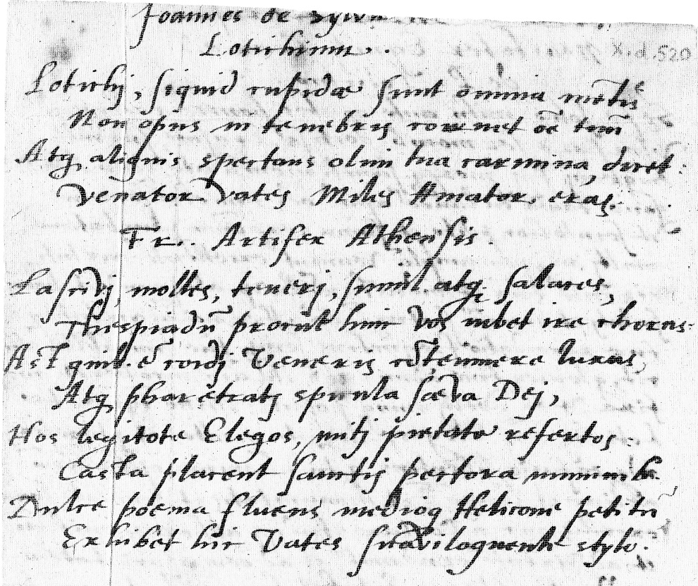

“Autograph copy in the hand of Edmund Spenser. The letter and poems were written on blank leaf m8 of Sabinus’ *Poëmata* (1576). Spenser’s copies of two poems, ‘Joannes de Sylva ad Lotichium’ by Jean Dubois, and ‘Fr. Artifex Athensis’” (Washington, D.C., Folger Shakespeare Library).

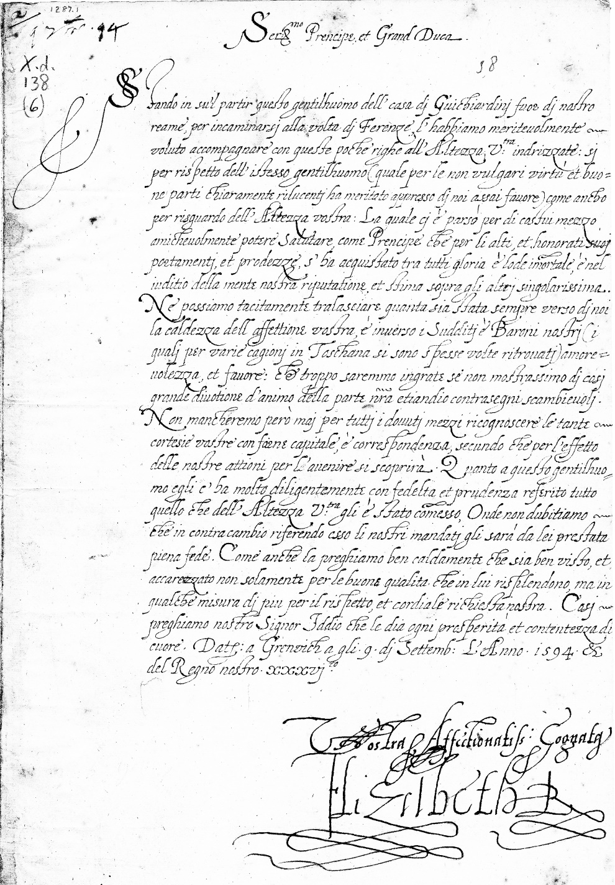

“Letter from Elizabeth I, Queen of England, Greenwich, to Don Ferdinando de Medici, Grand-Duke of Tuscany, 1594 September 9” (Washington, D.C., Folger Shakespeare Library).

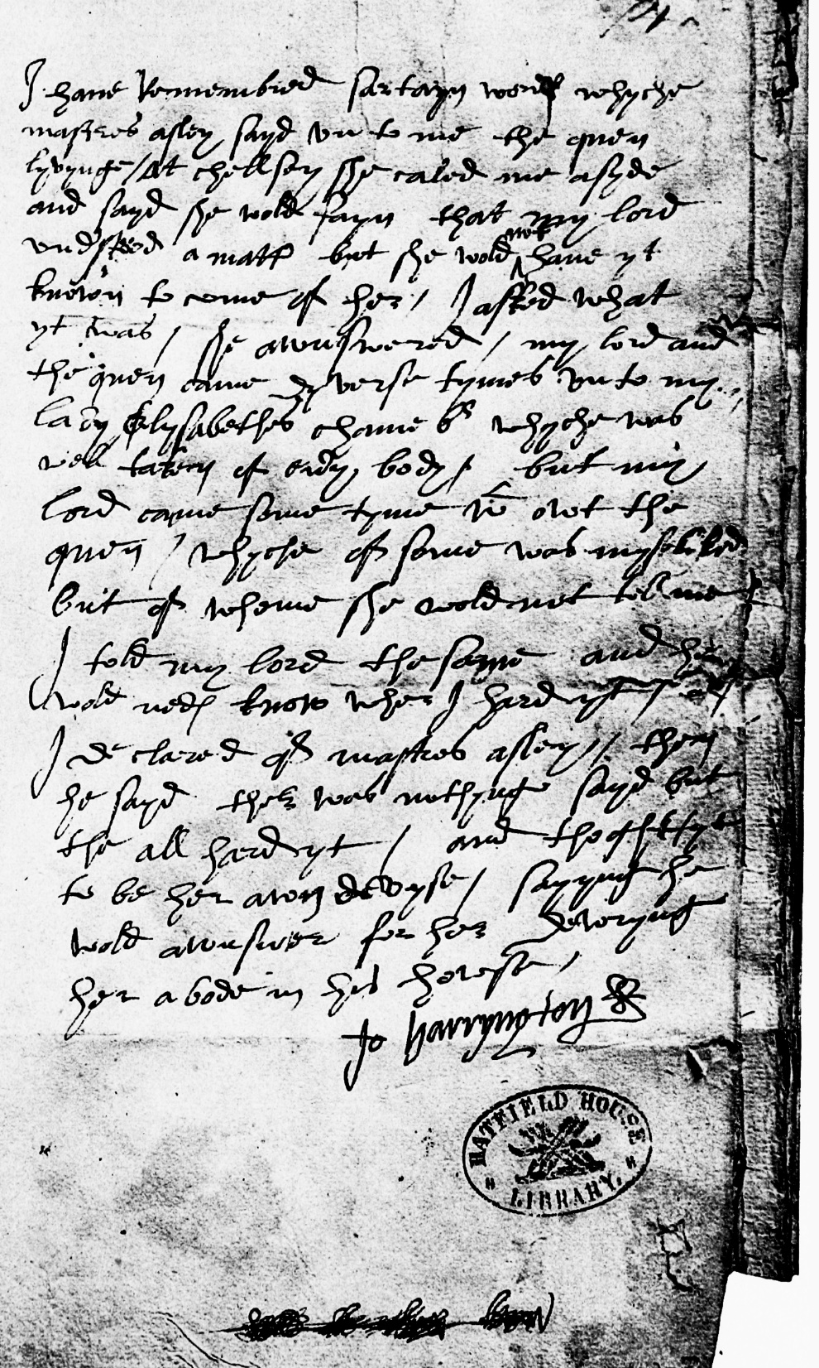

“Hand of John Harington the Elder in Cecil Papers 150, folio 74r”, *The Arundel Harington Manuscript* (1960).

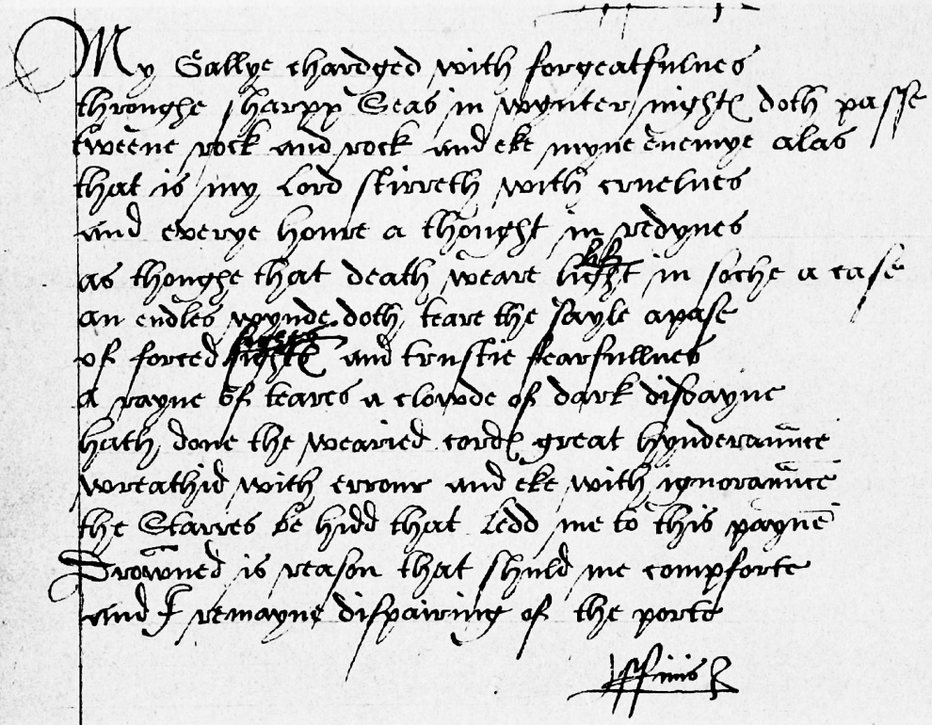

“Hand A in Poem No. 112, folio 66v”, *The Arundel Harington Manuscript* (1960).

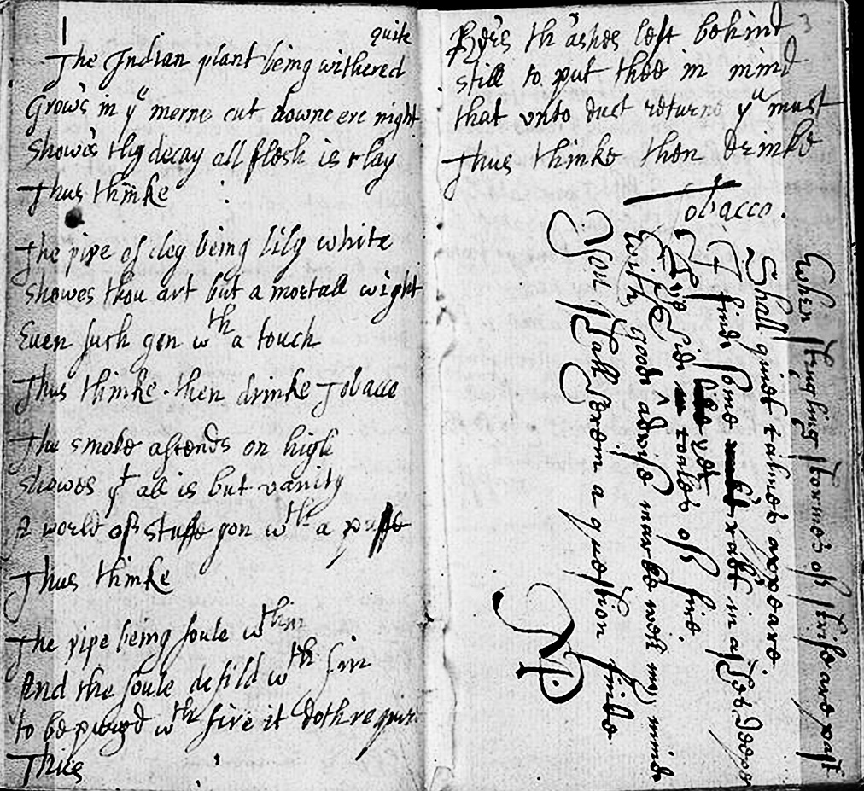

Anonymous, *Commonplace Poetry Book Collection*, includes a combination of two different handwriting styles (perhaps, Sylvester and Harvey’s) in “The Indian Plant Being Withered” and the “Shakespeare”-bylined Sonnet 2 (James Marshall and Marie-Louise Osborn Collection, Beinecke Rare Book and Manuscript Library, Yale University).

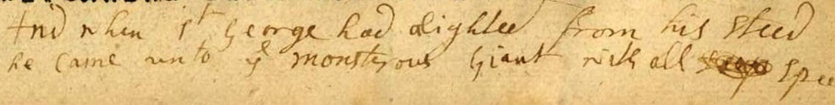

Handwriting in the margins of Page F in “Richard Johnson’s” *The Famous History of the Seven Champions of Christendom, The Second Part*.

**Richard Verstegan’s Group of Handwriting Variants**

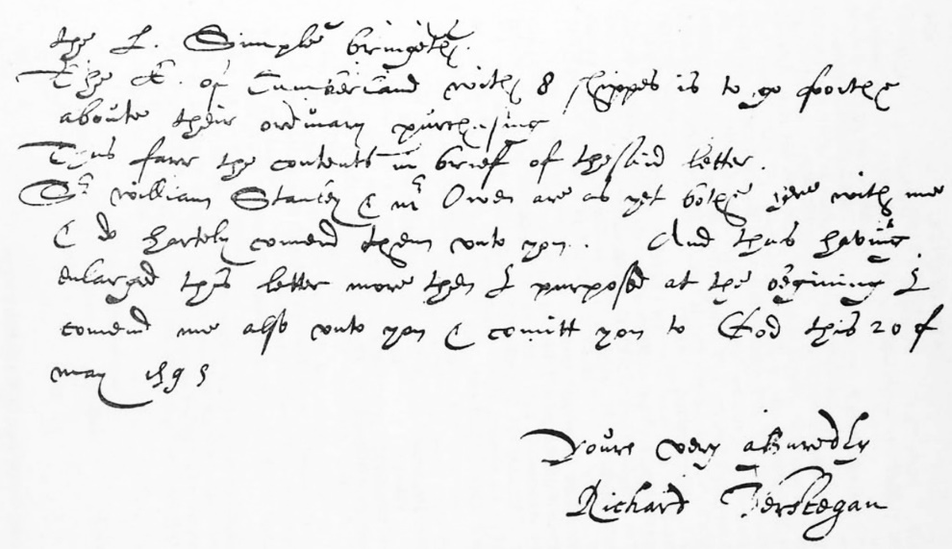

Verstegan’s Handwritten Letter in Anthony G. Petti’s *The Letters and Despatches of Richard Verstegan* (London: 1959).

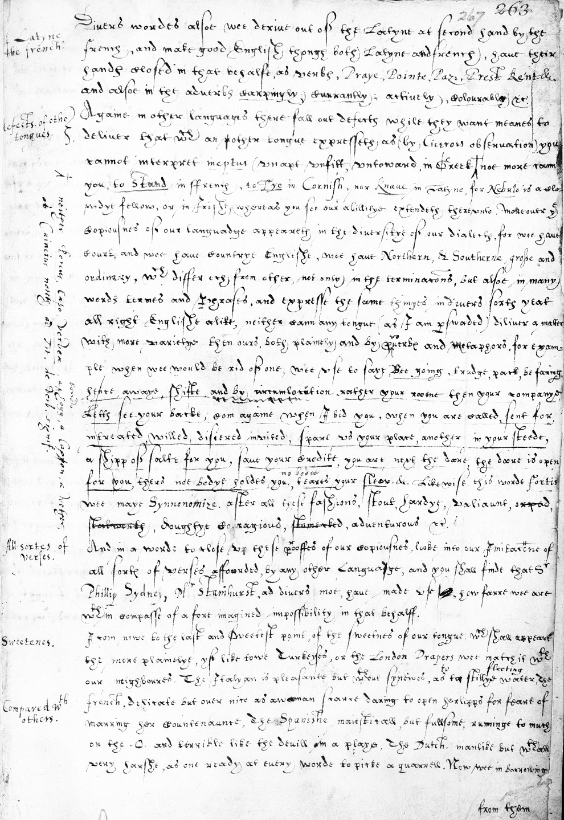

Handwritten draft of Richard Carew’s “The Excellency of the English Tongue”, published in William Camden’s *Remains of a Greater Work Concerning Britain* (London, 1605; The British Library), *Cotton Julius* *F XI*, fol. 267r-v.

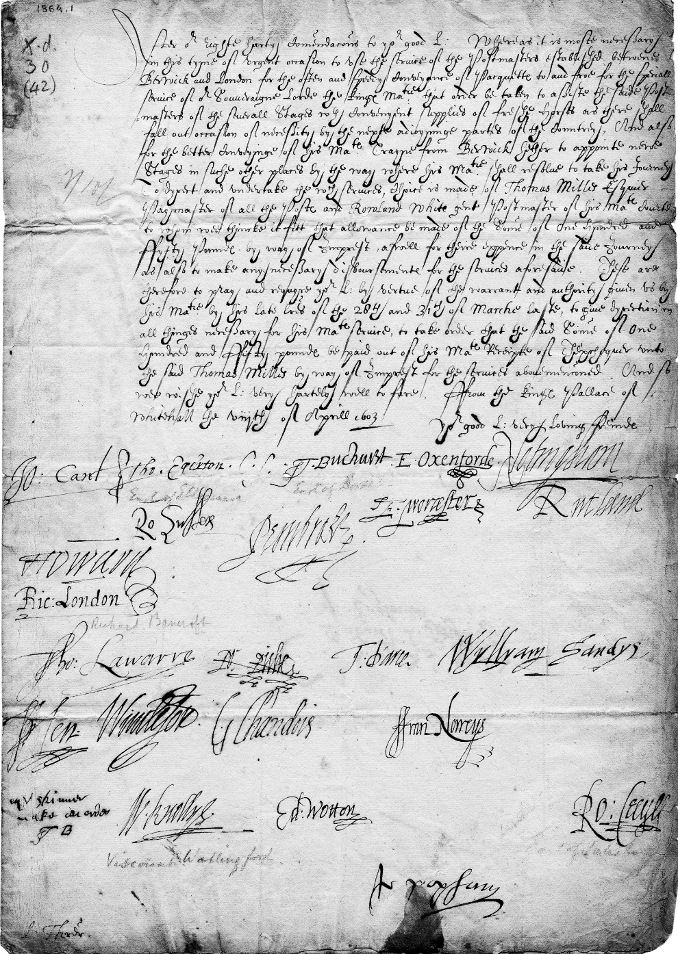

“Letter signed from the Privy Council, Whitehall, to Thomas Sackville, Baron Buckhurst, Lord High Treasurer of England. Directing payment to Thomas Myles, paymaster of the post, for him to ensure a fresh supply of post-horses along the route from Berwick to London to transport James I and his train on his accession. Signed by John Whitgift (‘Jo. Cant.’); Thomas Egerton; Thomas Sackville, Earl of Dorset (‘T. Buchurst’); Edward De Vere, Earl of Oxford (‘E. Oxenforde’); Charles Howard, Earl of Nottingham; Robert Radcliffe, Earl of Sussex; William Herbert, Earl of Pembroke; Edward Somerset, Earl of Worcester; Roger Manners, Earl of Rutland; Thomas Howard, Earl of Suffolk (‘T. Howard’); Richard Bancroft (‘Ric. London’); Thomas West, Baron de la Warr (‘Tho. Lawarre’); Robert Rich, Earl of Warwick (‘Ro. Riche’); Thomas Darcy, Earl of Rivers (‘T. D’arce’); William Sandys; Hen. Windesor?; Grey Brydges, Baron Chandos (‘G. Chandois’); Francis Norris, Earl of Berkshire (‘ffran. Norreys’); William Knollys, Earl of Banbury (‘W. Knollys’); Edward Wotton, Baron Wotton; Robert Cecil, Earl of Salisbury (‘Ro: Cecyll’), Sir John Popham Endorsed: 8 April 1603. The nobilities & late Privy Counsel. for an Imprest of £150 to Mr. Thomas Milles payment of the posts” (Folger Shakespeare Library: LUNA).

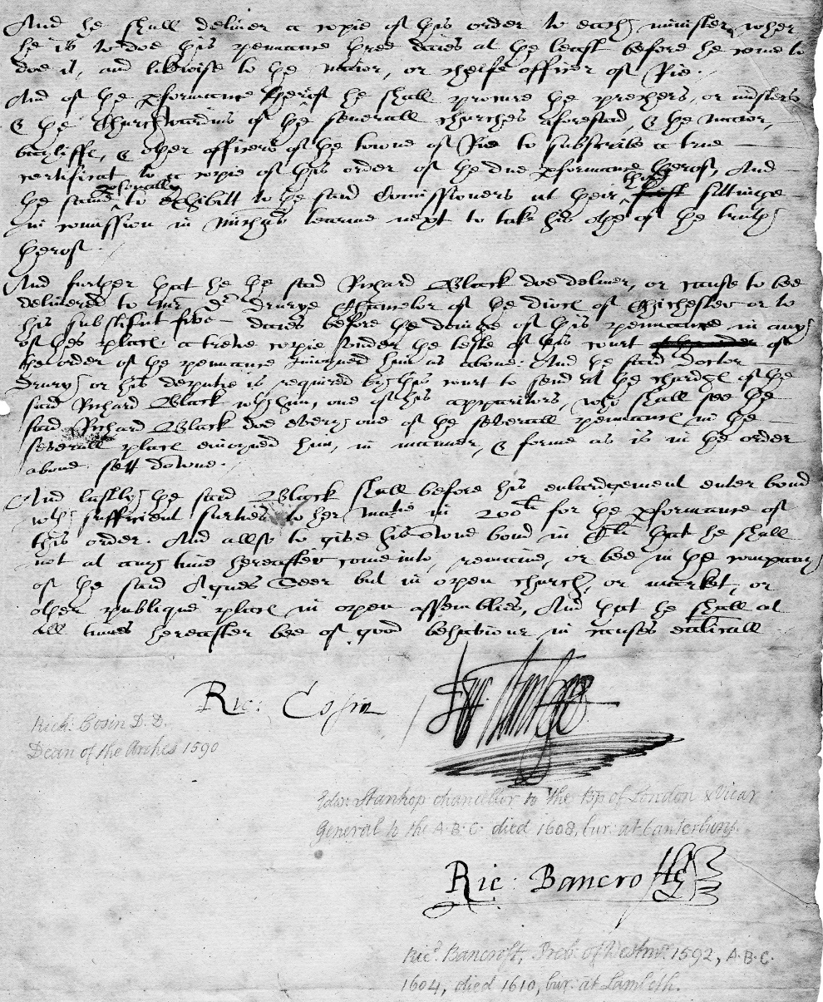

“Order of penance by the Court of High Commission enjoined on Richard Black of Iden, Sussex: 1594 September 19. Signed by Richard Cosin, Edward Stanhope and Richard Bancrofte” (Folger Shakespeare Library: LUNA).

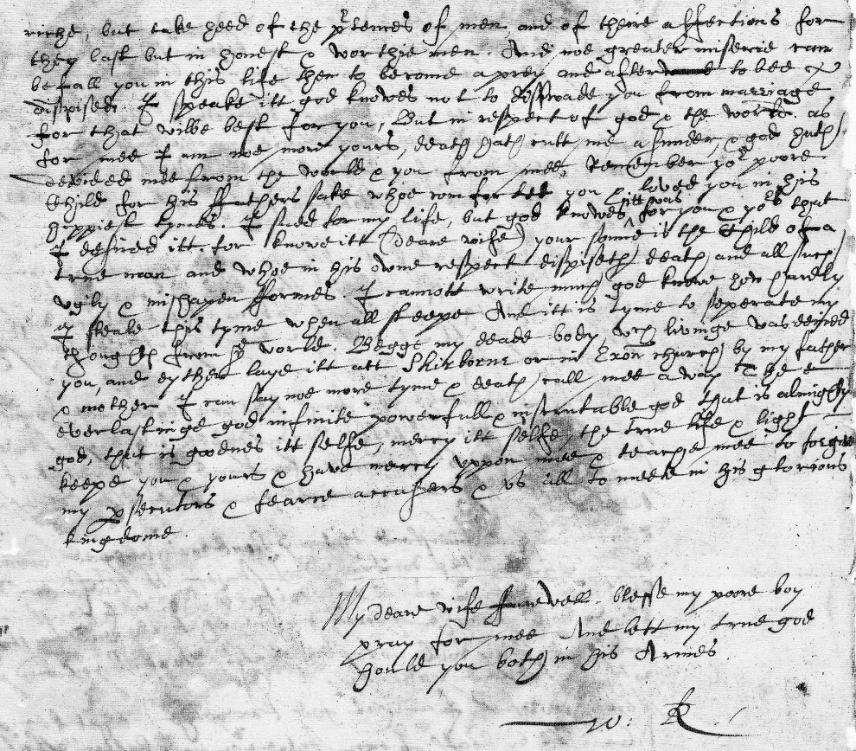

“Letter from Sir Walter Raleigh to Lady Elizabeth (Throckmorton) Raleigh, his wife: December 1603” (Folger Shakespeare Library: LUNA).

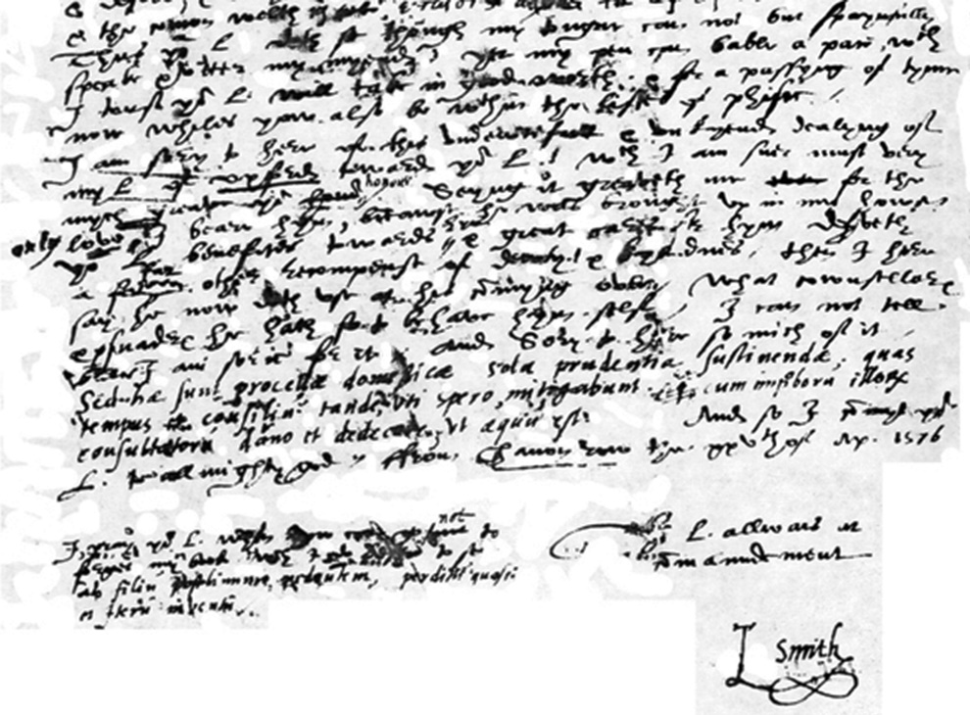

Sir Thomas Smith’s letter to Cecil on April 25, 1576 (PoliticWorm).

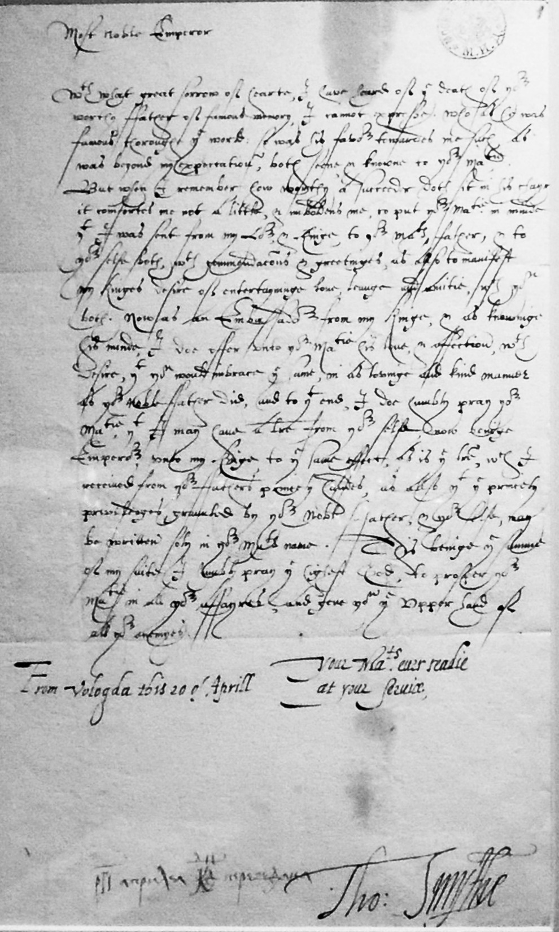

“Thomas Smythe’s letter to Fedor II of Russia”, April 20, 1605 (Wikipedia: Shakko).

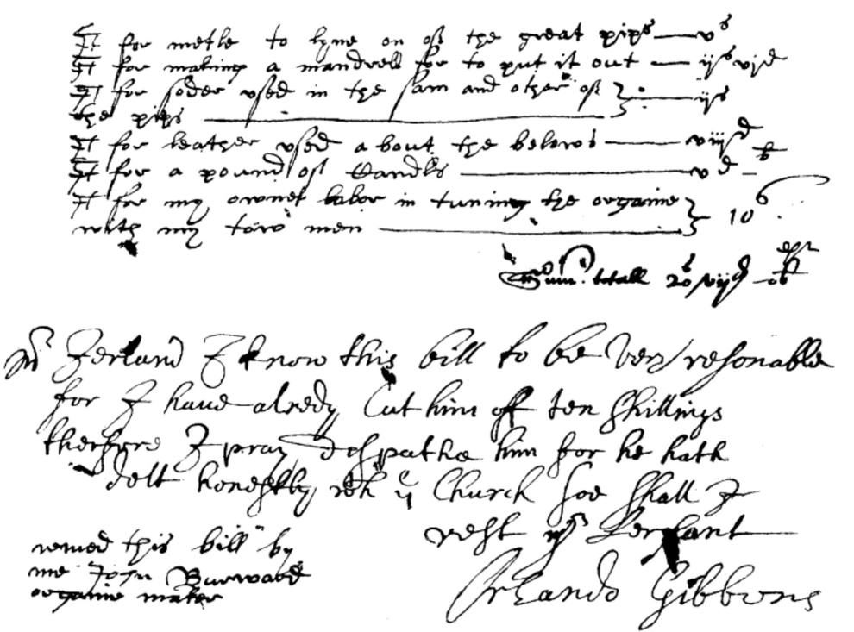

“Organ Builder’s Bill, Containing the Rare Signature of Orlando Gibbons” (Archives of the Dean and Chapter; *Musical Times*: August 1904).

***William Byrd’s Group of Handwriting Variants***

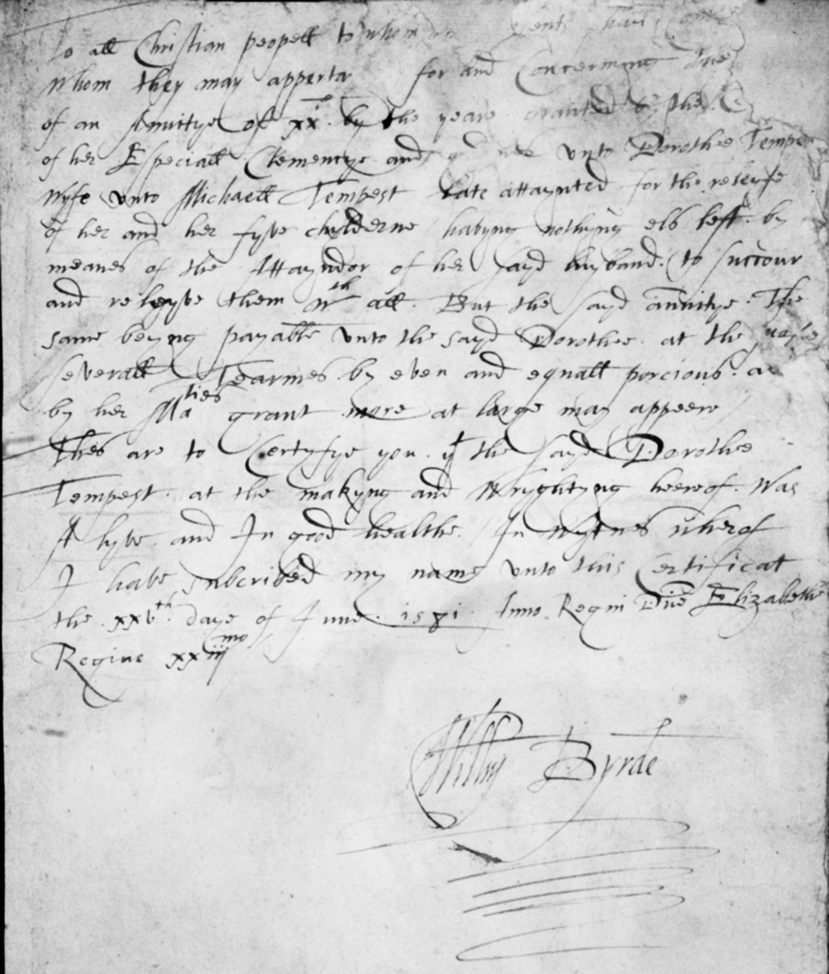

William Byrd’s Autograph on a Certificate on Behalf of Dorothy Tempest, June 25, 1581 (British Library, MS Mus. 1810/26).

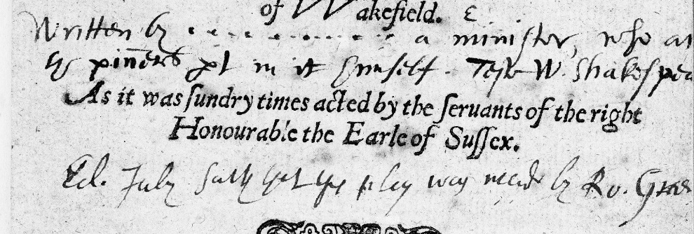

Inscription on *George of Green* (1599): “Written by… a minister, who ac[ted] the pinner’s part in it himself. Test W. Shakespea[re]/ Ed. Judy says that this play was made by Ro. Gree[ne]” (Folger Shakespeare Library).

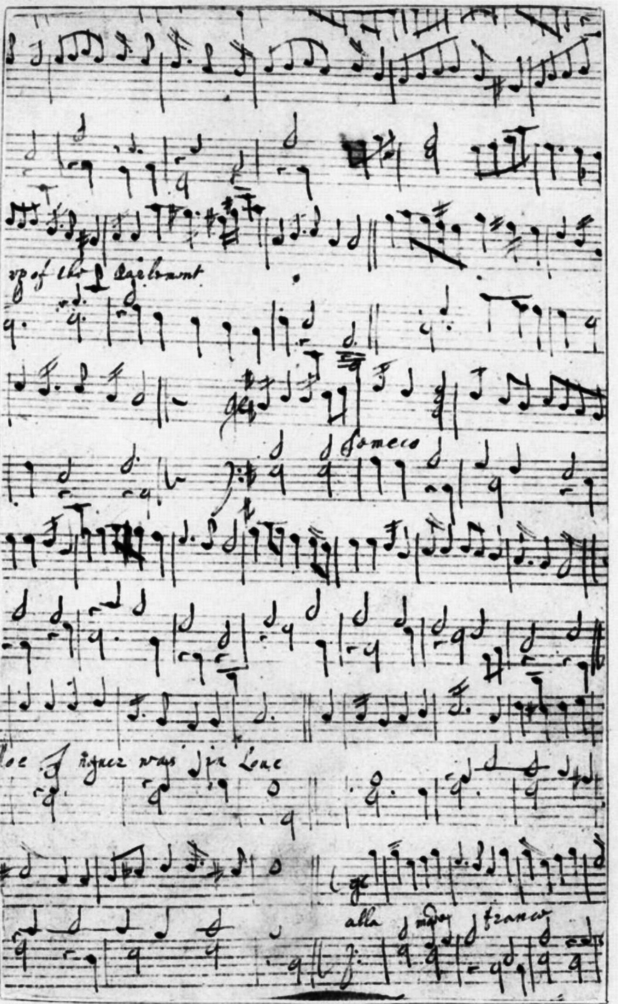

Gibbons and Byrd’s *Parthenia*: Handwritten Keyboard Pieces on the Reverse of the Title-Page and Dedication.

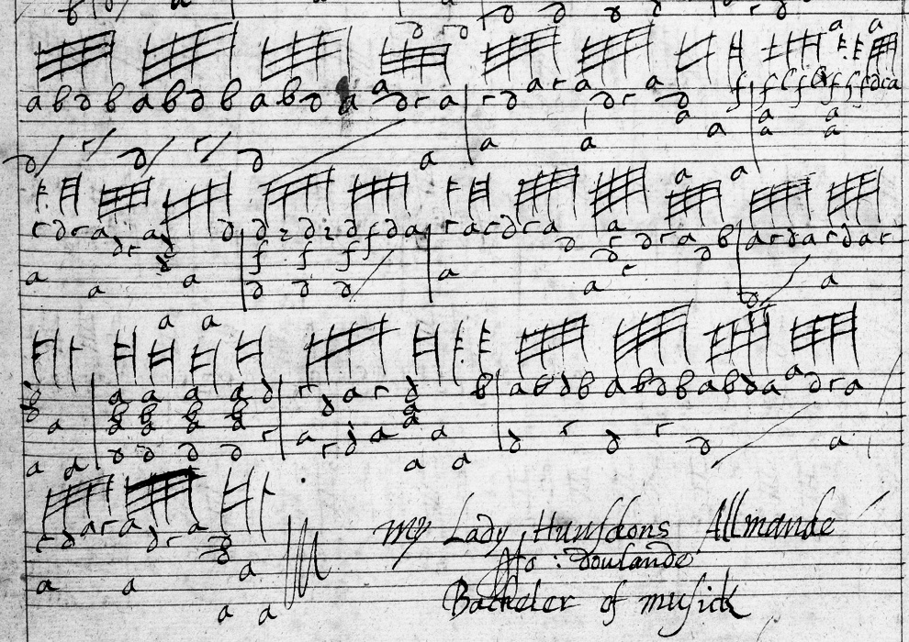

John Dowland’s “My Lady Hunsdon’s Allmande”, *Folger Lutebook*, f22v.

1. Hilton Kelliher and Katherine Duncan-Jones, “A Manuscript of Poems by Robert Sidney: Some Early Impressions”, *British Library Journal*, 107-44.